# INTRODUCTION

The evolution of wireless communication plays a vital role in the industry 4.0 campaign. Wireless systems are employed in different dimensions like security, manpower, machine learning, database management systems and so on. Here, wireless controlled RCC car is a result of networking patriarchy. Wi-Fi technology is an abundant technology for communication, data transfer as well as data management. But, none of us utilize the complete profit out of it rather than us. By using these concepts, an RC car is built using Wi-Fi that is ESP8266 NodeMCU in our research work we will see about the model and working of the car.

## PROBLEM DEFINITION

The traditional wired buttons controlled robot becomes very bulgy and it also limits the distance the robot goes. The Wireless Hand controlled Robot will function by a wearable hand glove from which the movements of the hand can be used as the input for the movement of the robot.

Conventionally, robots controlled by wireless communication employ radio frequency (RF) circuits, which have the drawbacks of limited working range, limited frequency range and the limited control. Use of a mobile phone for robotic control can overcome these limitations. It provides the advantage of robust control, working range as large as the coverage area of the service provider.

The aim of the project is to develop a human machine interface used for control robot arm. Our objective is to make this device simple as well as cheap so it can be produced and used for number of purposes. The objective of this project is to build a car that can be controlled by gesture wirelessly. In this project user is also able to control motions of the car by wearing controller glove and performing predefined gestures. This can be also used in many potential applications such as wireless controller car racing etc.

# RELATED WORK (LITERATURE SURVEY)

1. Yuxin Jing, Letian Zhang et-al implemented “An android Remote Control Car Unit for search missions “It is used in mean to be in a search for natural disasters. It has accomplished with the autonomous development to control the robot from anywhere of the world. Requirements for it’s implementation are Camera, ESP8266, DC Motor, Cloud service Android application. This application can make search operation more easier.
2. AyanMaity et-al implemented “Android application based Bluetooth controlled robotic car” Robot is controlled with the help of Bluetooth it is useful in moving vehicle forward, backward, left, right are Arduino UNO (ATMEGA 32), Bluetooth module (HC-05), Smart phone, Motor driver (I293D).Main purpose of this robot is to detect hidden mines
3. Rahul Kumar et-al implemented “Android Phone Controlled WiFi Robot” This paper deals with design and control of vehicle capture live streams and videos at required location. Requirements for its implementation are Arduino Uno Board,ESP8266, DC Motors, Uart, L293D Motor Driver IC, Power adapter.
4. MehmetcanGule, Murat, Orthun et-al implemented “Android Based Wi-Fi Controlled robot using Raspberrpi” In this paper implementation is done for robot forward, backward, left, right and to display live stream of video using USB camera and raspberry pi board. Most inventive application is implemented to make people lives easier.
5. Jan Nadvornik, Pavel, Smutny et –al studied “Remote Control Robot Using Android Mobile Device”. The application allow robot to control interaction with display or voice when we use graphical user interface we can monitor current distance of obstacle from vehicle. Ultrasonic sensors are used to find distance of obstacle from vehicle.

## Disadvantage of the existing system-

Majority of the industrial robots are autonomous as they are required to operate at high speed and with great accuracy. But some applications require semi-autonomous or human controlled robots. Robots can certainly handle their precribed tasks, but they typically cannot handle unexpected situations.

Many robots installed in workplaces still require manual labour attached to them. Training those employees on how to work with robots definitely can cost more.

Some of the most commonly used control systems are voice recognition, tactile or touch controlled and motion controlled. Instead of using a remote control with buttons or a joystick, the gestures of the hand are used to control the motion of the robot.

## Advantages of the proposed System-

The mobile controlled robot that has ability to move in different directions according to user’s keypress and to capture images of remote location.

This is a robot with wireless visual system that the user can observe and control the movements via mobile.

The advantages are as follows

1. Wireless control.
2. Noise free operation.
3. Unlimited control options.
4. Vehicle Navigation with use of 5G technology.
5. The operation is quite simple.
6. Takes in use of the mobile technology which is almost available everywhere.
7. This wireless device has no boundary of range and can be controlled as far as network of cell phone.
8. From a performance standpoint, the perceived benefits of a robotic security or surveillance capability are numerous and well documented.
9. Humans are removed from direct exposure to potentially dangerous situation.
10. Robotic systems can perform many security and surveillance functions more effectively than humans.

**2.3 APPLICATIONS-**

* Cell phone controlled robot can be used in the borders for displaying hidden Land mines.
* The robot can be used for reconnaissance or surveillance.
* The robot can be used anywhere there is the service provider tower of the connection provided that is mounted on robot.
* It can be adequately implemented in national defense through military-industrial partnership.
* It can be vastly applied in Resorts, borders of noted buildings.
* Installation of combat robots in the stadiums, sacred places, government and non government organizations assures top security.

# HARDWARE AND SOFTWARE REQUIREMENTS

## Hardware components:

* NodeMCU ESP8266
* L298A Motor Driver IC
* LED
* 2 Geared Motors with Wheels
* Car Chassis
* Batteries

## Software components:

* Arduino IDE 1.8.13
* Blynk Cloud

# PROPOSED WORK

Wi-Fi P2P allows your application to quickly find and internet with nearby devices, at a range beyond the capabilities of Bluetooth. Wi-Fi is faster than Bluetooth. With the help of Wi-Fi you will be able to get connected with the nearby devices without needing to connect to a network or hotspot. If Application is designed to be a part of a secure, near-range network, Wi-Fi direct is suitable option for networking for the following reasons Wi-Fi uses WPA2 encryption and makes sure that privacy of the data will be maintained. Broadcasting of the services will be done to identify suitable peer. To determine which device is of which group power management of the Wi-Fi devices will be checked, UI, and service capabilities can be easily handled by server more effectively.

Android application consist of five Activities first is it provides module to generate signals for Acceleration, Steering, Brake and pass it to microcontroller usage of Wi-Fi media will be done for the transmission of the signals.

The system will be divided into two sections one will be transmitter section and other will be receiver section. The transmitter section will consists of Blynk Cloud App. The receiver section consists of one NodeMCU ESP8266, one motor driver IC, two wheels.

Here we will require two separate 5 volt power supply which will be applied to both the sections. Finally, the NodeMCU ESP8266 will reads the Blynk Cloud App output values i.e., x-axis and y-axis values.

The robot moves forward, backward, right and left when there is tilt in the palm of user in forward, backward, right and left respectively directions. A gesture controlled robot can be controlled by using hand in place of any other method like buttons or joystick.

**5. INTEGRATED TECHNOLOGIES**

## Components Description

#### 5.1.1 NodeMCU

NodeMCU is a microcontroller though it is already integrated with esp12. It is most preferable for IoT start-up students. It is applicable for the devices using wi-fi as well as tethering hotspot. In such a prototype the NodeMCU connects with the router, which possesses an IP address that can be employed by our pc or mobile. So, that we can host or control the prototype by means of such application installed.

### 5.1.2 L293D MOTOR DRIVER

It is a motor driver, has 16 pins. First pin and pin number 9 are enable pins. When you give the power to enable one (on the left side) all the pain on the left side gets activated and while when you provide a 5 V to enable 2 (on the right side), all the pins on the right side gets enabled.

### 5.1.3 Power Source

To generate required power source to drive the vehicle 12V, 1.2A, rechargeable, lead acid heavy duty battery is used. Two different DC levels of +5V & +12V are used. The DC motors are designed to operate at 12V DC & each motor consumes a maximum current of 150 milliamps, there by two motors together consumes 300 milli-amps, the remaining circuitry including microcontroller will consume another 150 milli-amps, hence the entire system consumes around 450 milli-amps approximately.

### 5.2.8 Other Components

LED, Connecting wires, 2 Geared Motors with Wheel, Robot Car Chassis.

## 6. SYSTEM ARCHITECTURE

**6.1. Block diagram of the project**

* **Transmitter Block Diagram/ Receiver Block Diagram:**

NodeMCU Wifi Module

Smartphone

Blynk Cloud App

Motor Right

Motor Driven IC

Motor Left

**Fig. 1 : Block diagram of smartphone controlled robot car**

First we need to download and install the Blynk Cloud App in the smartphone and select the joystick type in the app and configure the joystick in the app. Then we need to configure the Wi-Fi module and connect it to a hotspot. Whatever the input instructions are received from the joystick of the Blynk Cloud App, the Wi-Fi module receives the instructions and the NodeMCU processes the information as shown in the figure. After that the NodeMCU instructs the Motor Driver IC to supply power to the 2 motors according to the input given by the user.

**7. METHODOLOGY**

**7.1. Circuit diagram**

* **Circuit Diagram for Transmitter Section:**

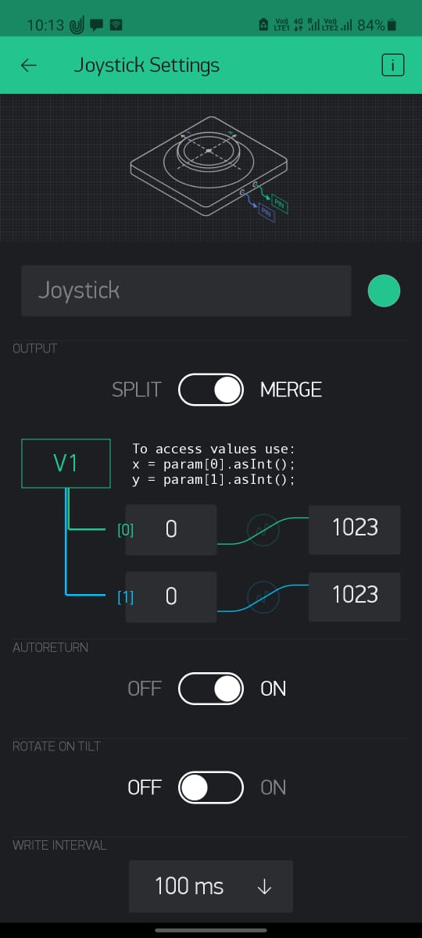

**Fig 2.a: Circuit diagram of Joystick Coordinates**



**Fig. 2.b: Coordinate Configuration of joystick**

* **Circuit Diagram for Receiver Section:**

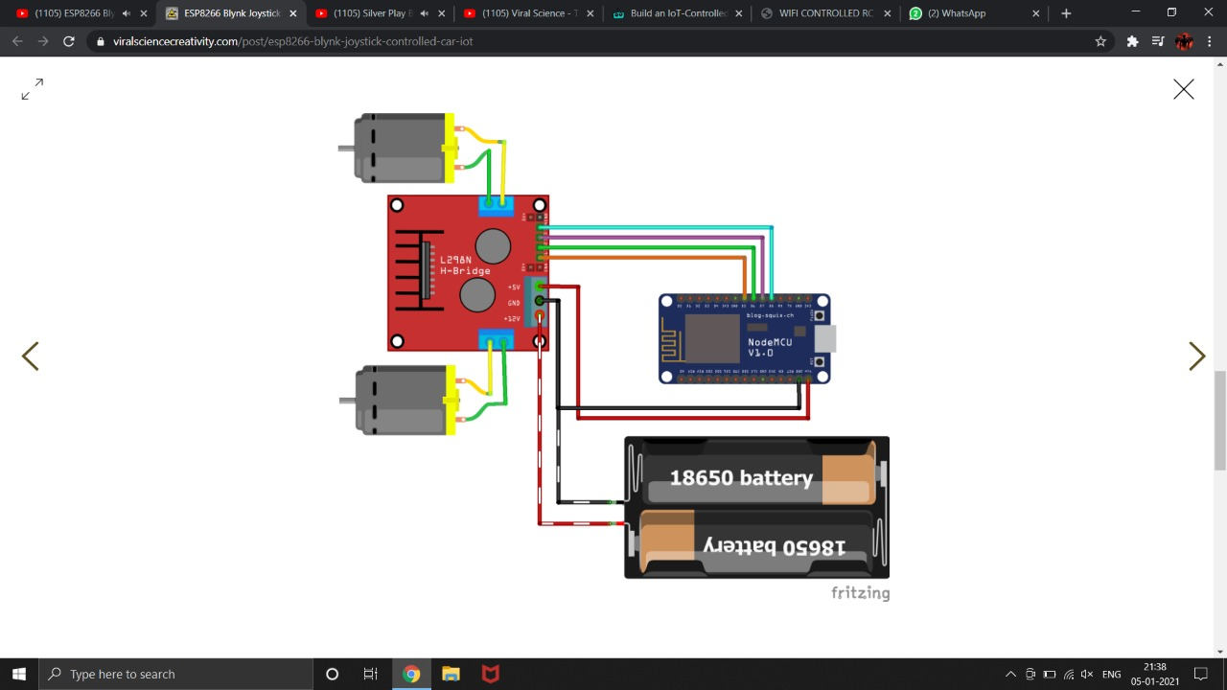

**Fig 3: Circuit diagram of the components of robot car**

**8. RESULTS DISCUSSION**

The Robot control system has the ability to move in different directions such as left, right, forward, backward and stop according to user’s keypress. This is a robot with wireless visual system that the user can observe and control the movements via mobile. The primary purpose of the mobile phone operated land rover with DTMF decoder is to know the information in the places where we cannot move.

* Stop Condition At the point when the joystick position is even arrangement, (y < maxRange && y > minRange && x < maxRange && x > minRange) which makes robot to stop.
* Forward condition at the point when the joystick position is tilted to advance. (x >= maxRange && y >= maxRange) which makes robot to push ahead
* Backward condition at the point when the joystick position is tilted to towards in reverse position. (y <= minRange && x >= minRange && x <= maxRange) which makes robot to move in reverse.
* Right condition at the point when the accelerometer position is tilted to towards right position (x >= maxRange && y >= maxRange) which makes robot to move towards right.
* Left condition at the point when the accelerometer position is tilted to towards left position (x <= minRange && y >= maxRange) which makes robot to move towards left.
* Backward Right condition at the point when the accelerometer position is tilted to towards right position (y <= minRange && x <= minRange) which makes robot to move backwards right.
* Backward Left condition at the point when the accelerometer position is tilted to towards left position (y <= minRange && x >= maxRange) which makes robot to move backwards left.

**8.1 Snapshots:**

* Wi-Fi Robot Car

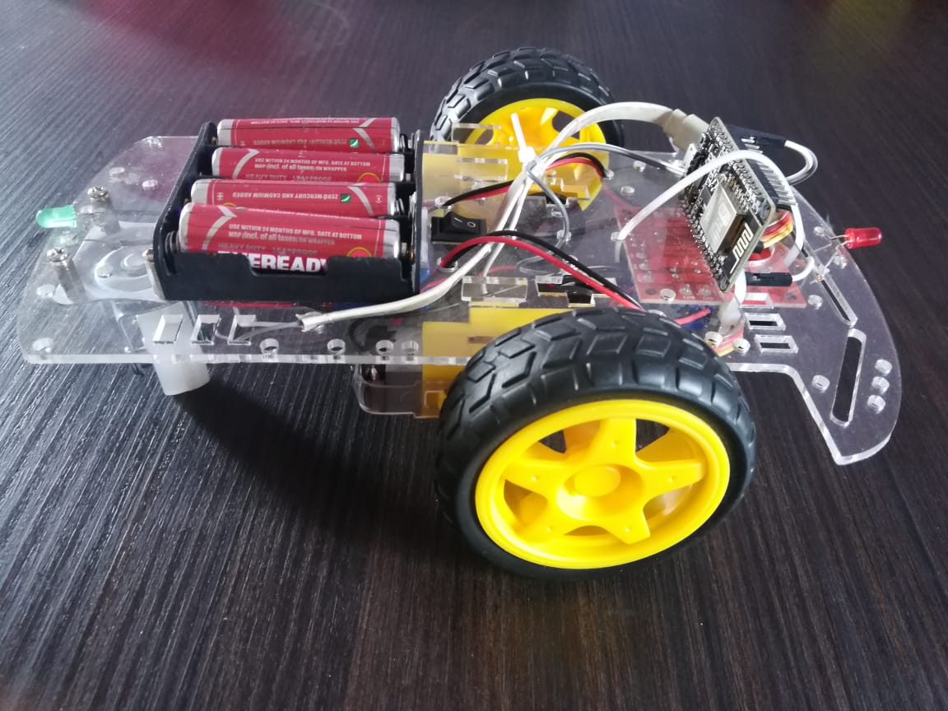

* Blynk Cloud App

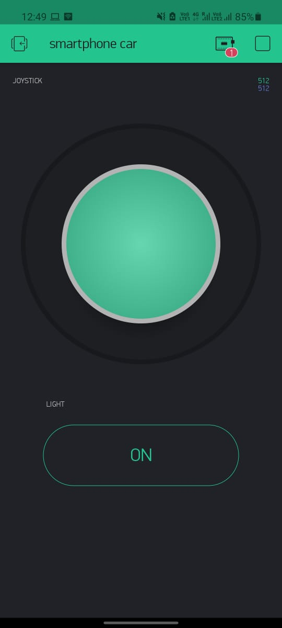

**9. CONCLUSION AND SCOPE FOR FURTHER ENHANCEMENT**

**Conclusion:**

This ideology can be used in automation industries, real-time control systems engineering, and industrial purposes. The whole prototype is applicable in both PC as well as android mobile with a Wi-Fi technology. A physical living matter can end up with imperfections but, a built-in prototype can’t make imperfections (or) errors. This ideology may possess finite drawbacks as similar with IoT.

The implementation and testing of the wireless car using WI-FI + IOT was done and the desired results were obtained. We successfully drove the car and the car can be used for surveillance purpose. We also tested the applications used to drive the car. Due to the new concept of Wireless Controlled Car using Wifi and IOT, we were able to come up with various possibilities that can take place. We were successful in making an android application that can be used for driving and giving commands to the car.

**Further Enhancement:**

* The on board batteries occupy a lot of space and are also quite heavy. We can either use some alternate power source for the batteries or replace the current DC Motors with ones which require less power.
* The proposed system is applicable in hazardous environment where a camera can be attached to the robot and can be viewed by the user who is in his station. This system can also be employed in medical field where miniature robot are created that can help doctors for efficient surgery operations.
* Entertainment applications – Most videogames today are played either on game consoles, arcade units or PCs, and all require a combination of input devices. Gesture recognition can be used to truly immerse a players in the game world like never before.

**10. BIBLIOGRAPHY**

1. Kena Patel, Bhavna K. Pancholi “A Novel fire extinguishing vehicle controlled by android application” Deparment of Electrical University of Baroda India IEEE International Conference on Smart Technologies and Management for Computing, ISSN 2231-4903, Vol.08, Issue 01, January-2018, PP.417-422
2. MehmetcanGule, Murat, Orthun “Android Based Wi-Fi Controlled robot using Raspberrypi”Computer Engineering Department Turkey 2017 IEEEInternational Conference of Computer Science and Engineering, ISSN -4799-3528, PP.978-982
3. Jayesh George, Adithyasreyaj, DanielJoseph, Sajeer P “Android Controlled Smart Car”International Journal of Computer Engineering in Research trendVolume2, Issue 12, December-2015, pp.1087-1090 ISSN (O): 2349-7084
4. <https://www.electronicshub.org/>
5. <https://www.instructables.com/>
6. <https://circuitdigest.com/microcontroller-projects/>
7. <https://www.gadgetronicx.com/>